**Assignment 1**

1.

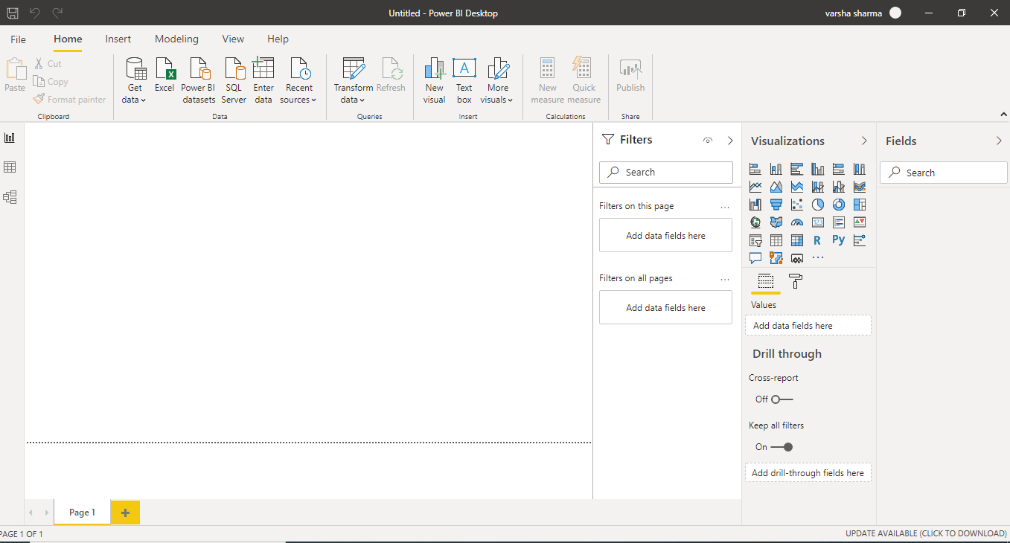

2.

Report View

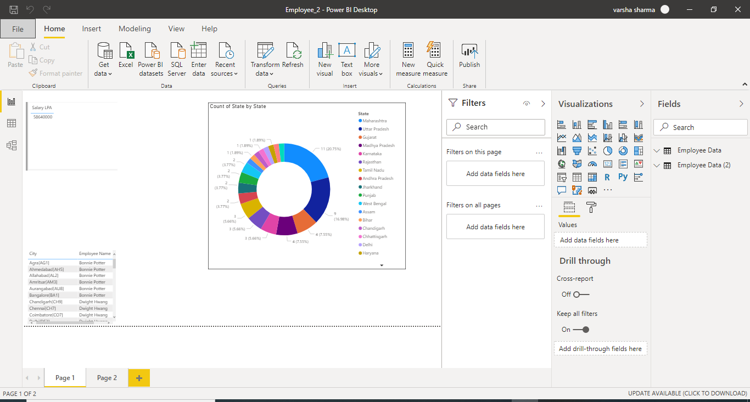

Data View

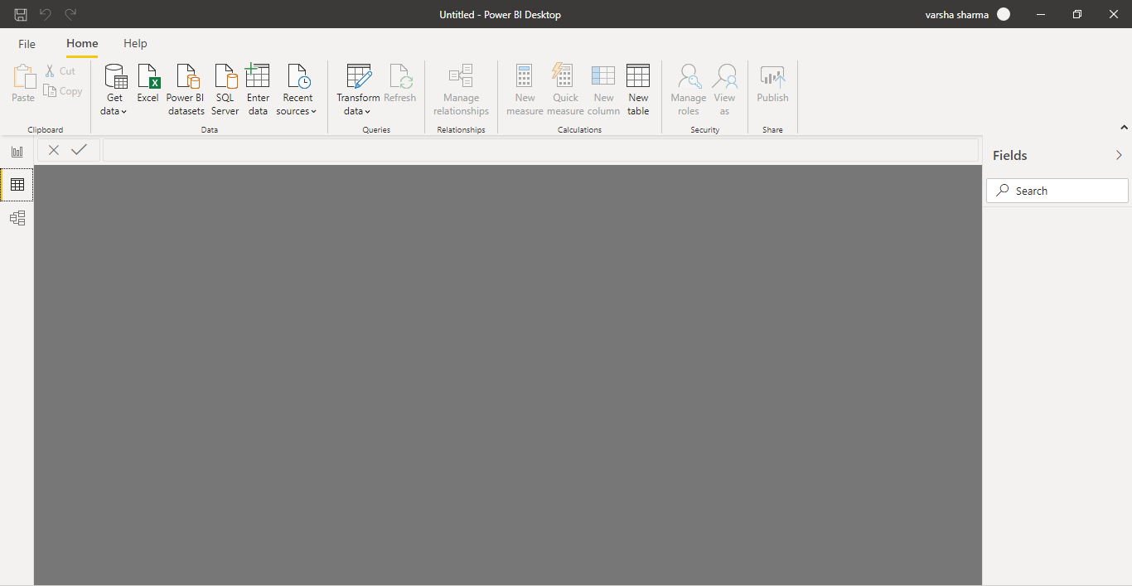

Model View

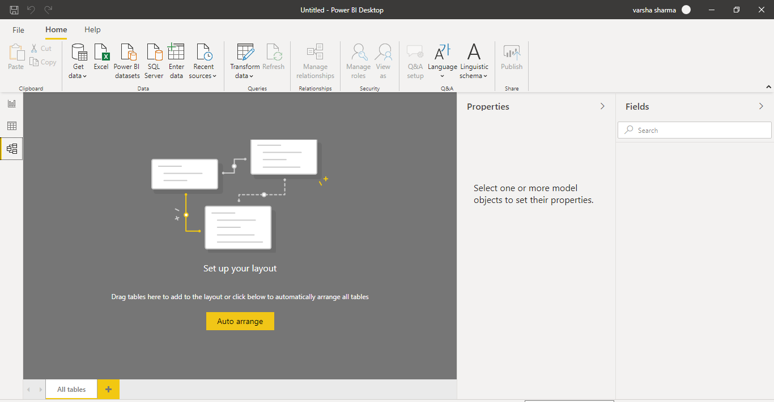

Power Query Editor

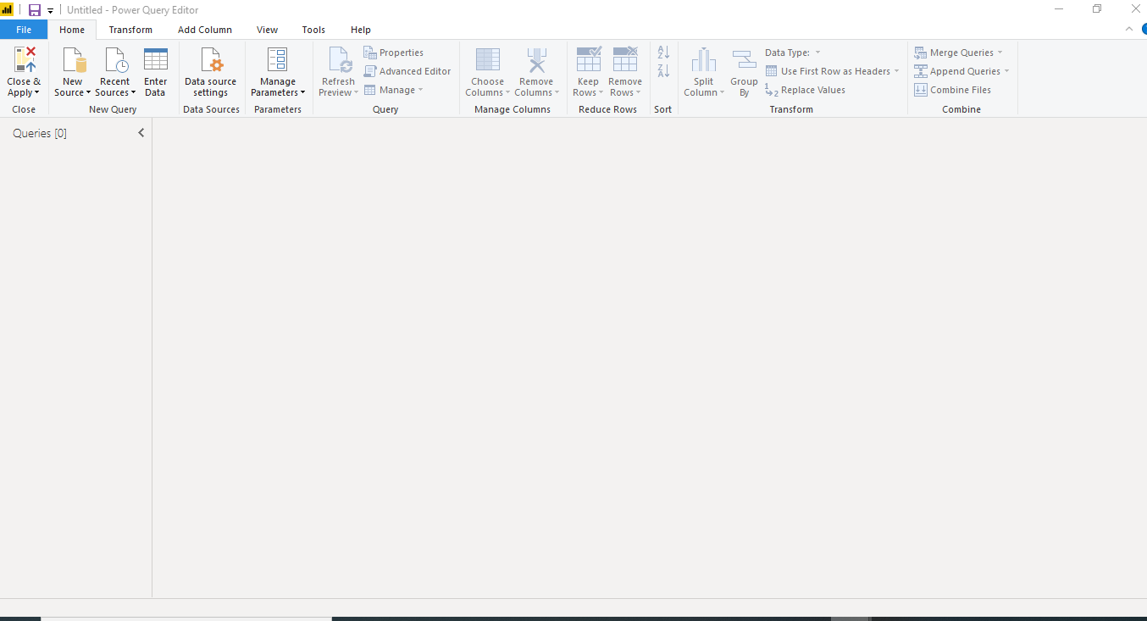

Advanced Editor

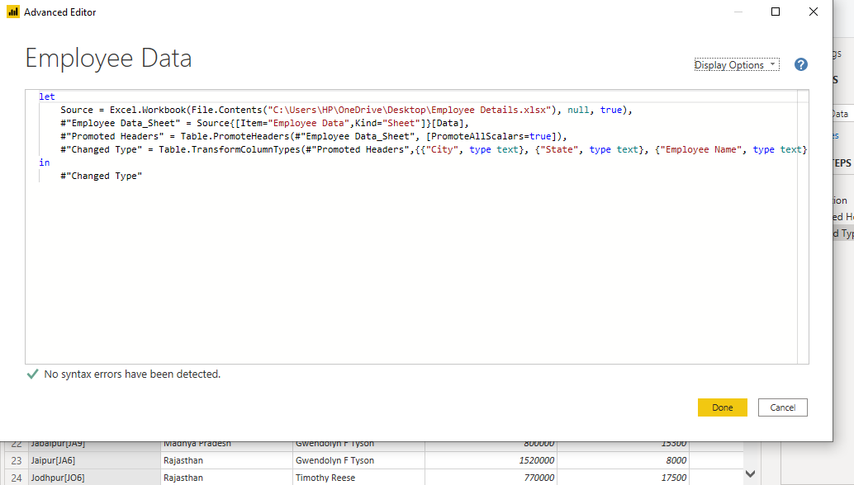

3.

* Power BI Desktop

**Price : Free**

1. Power BI Desktop is free version of Power BI that can be installed in our local systems and can be used by anyone.
2. It has the feature to connect and import data from over 70 cloud-based sources.
3. It has same rich visualisations and filters as its higher version Power BI Pro.
4. Can Export your data to CSV, Microsoft Excel, Microsoft Power Point and PDF.
5. Python Support
6. Storage limit of 10GB per user.
7. It cannot share created report with non-Power BI user.
8. It doesn’t have email subscription.
9. It doesn’t have support to analyse in Excel within Power BI Desktop.

* Power BI Pro

**Price : 660 Indian Rupees Monthly price per user**

1. Power BI Pro is full version of Power BI complete with the ability to use Power BI for both building dashboard and reports and unlimited viewing sharing and consumption of created reports. This feature is not available in Power BI Pro.
2. Ability to embed Power BI visuals into app.
3. Integration with Microsoft solutions.
4. We can also share dataset, dashboards and reports with other Power BI Pro users.
5. It is given as licensed per user. Example: If you have 5 employees for data analytics work you will have to have 5 licence. Although this disadvantage of this being bit expensive is sorted in Power BI Premium.
6. Maximum size of individual dataset is 1 G.
7. Maximum storage per user is 10G.
8. Lastly, the maximum number of automatic refreshes per day is 8.
9. Peer to Peer sharing is available with this one.

* Power BI Premium

**Price : 330190 Indian Rupees Monthly price per dedicated cloud compute and storage resource with annual subscription**

1. It is the most expensive one among all the three tiers of Power BI.
2. It has increased data capacity limits and maximum performance. E.g. Its compute processing environment is dedicated unlike Power BI Pro which has shared processing environment and maximum storage is 100TB.
3. It has larger storage sizes for extended deployment.
4. It is licensed by dedicated cloud compute and storage resources.
5. It even have Power BI Report Server.
6. In this the maximum size of individual dataset is 10 G.
7. The maximum number of automatic refreshes per day is 48.
8. It can even store Power BI data to Azure Data lake storage Gen2.
9. It also allows AI-powered data modelling using AutoML, Cognitive Services, and Azure Machine learning.